# Ritika Kumari- A20414073

# CSP554—Big Data Technologies

## Assignment #11

Exercise 1)

Create an HBase table with the following characteristics

Table Name: csp554Tbl

First column family: cf1

Second column family: cf2

Then execute the DESCRIBE command on the table and return command you wrote and the output as the results of this exercise.

**Command Executed:**

create 'cs595Tbl', {NAME => 'cf1'}, {NAME => 'cf2'}

describe 'cs595Tbl'

**Screenshots:**

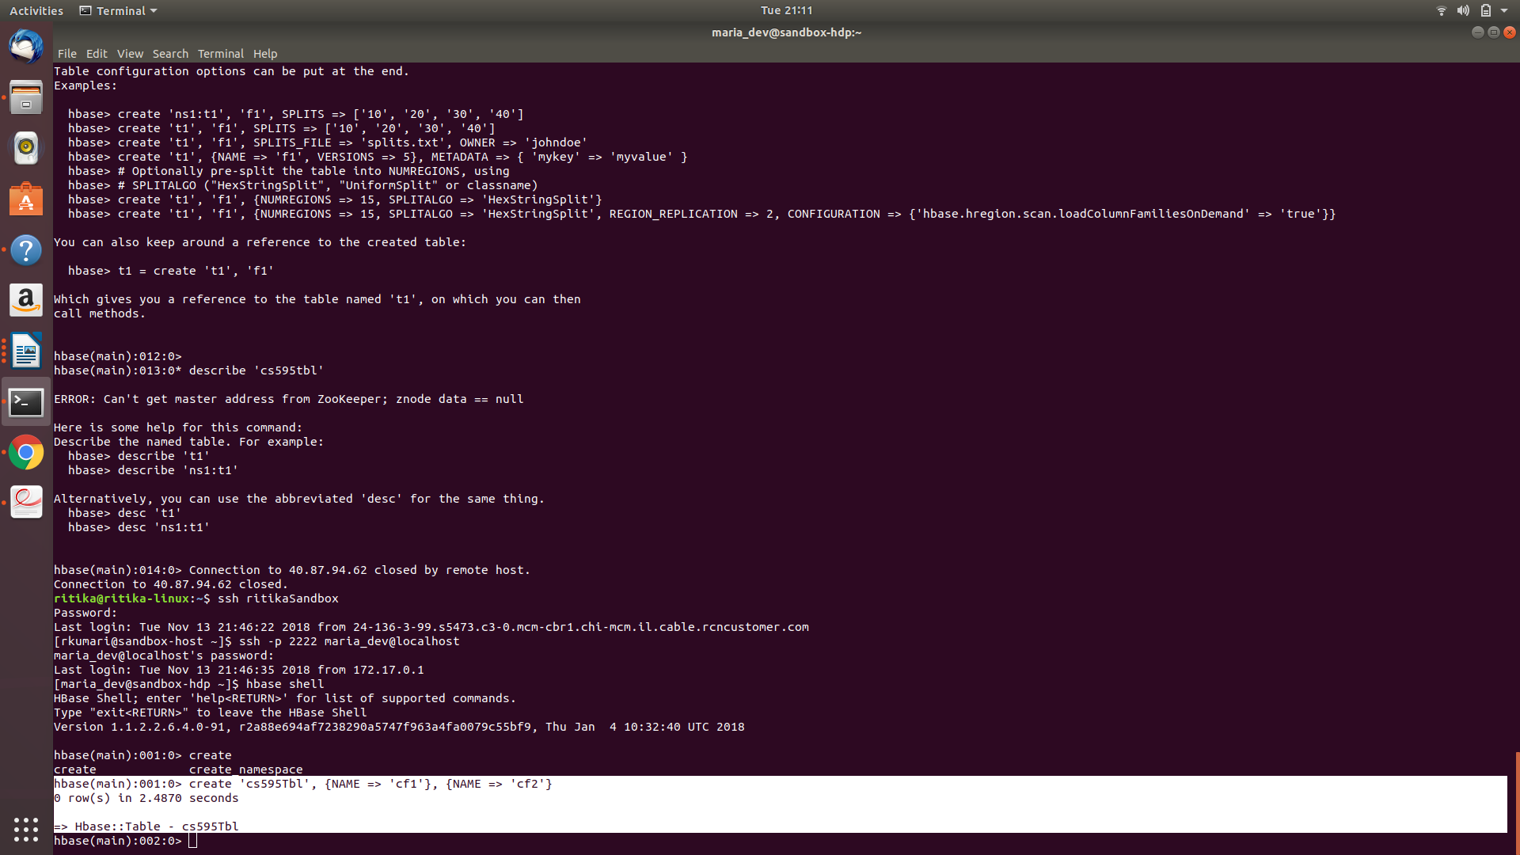

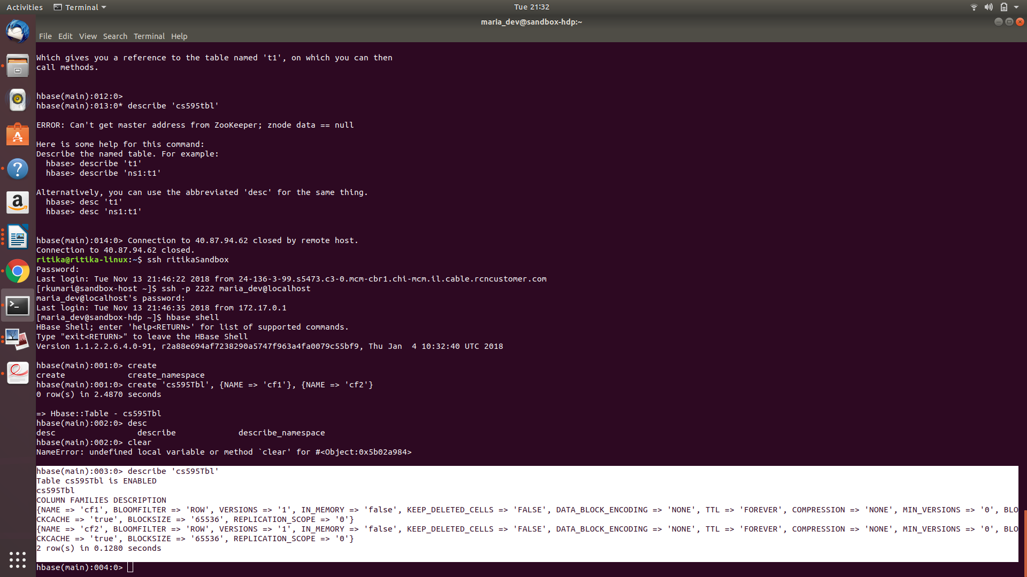

Exercise 2)

Put the following data into the table created in exercise 1:

|  |  |  |  |
| --- | --- | --- | --- |
| **Row Key** | **Column Family** | **Column (Qualifier)** | **Value** |
| **Row1** | cf1 | name | Sam |
| **Row2** | cf1 | name | Ahmed |
| **Row1** | cf2 | job | Pilot |
| **Row2** | cf2 | job | Doctor |
| **Row1** | cf2 | level | LZ3 |
| **Row2** | cf2 | level | AR7 |

Execute the SCAN command on this table returning all rows, column families and columns as the result of the exercise.

**Command executed:**

put 'cs595Tbl', 'Row1', 'cf1:Name', 'Sam'

put 'cs595Tbl', 'Row2', 'cf1:Name', 'Ahmed'

put 'cs595Tbl', 'Row1', 'cf2:Job', 'Pilot'

put 'cs595Tbl', 'Row2', 'cf2:Job', 'Doctor'

put 'cs595Tbl', 'Row1', 'cf2:Level', 'LZ3'

put 'cs595Tbl', 'Row2', 'cf2:Level', 'AR7'

scan 'cs595Tbl'

**Screenshots:**

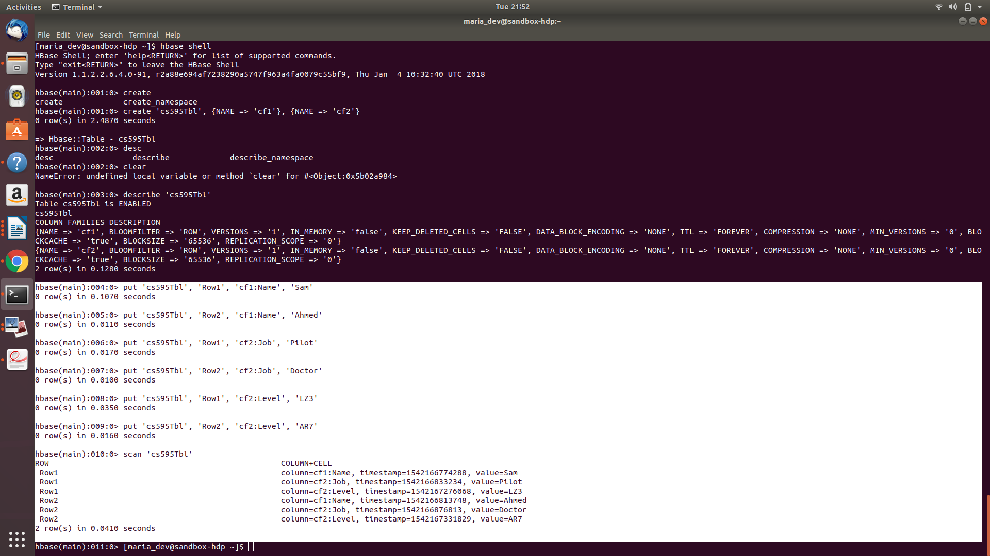

Exercise 3)

Using the above table write command that will get the value associated with row (Row1), column family (cf1) and column/qualifier (level). Provide the command and its result as the output of this exercise.

**Command Executed:**

get 'cs595Tbl', 'Row1', {COLUMN => [ 'cf1', 'cf2:Level']}

**Screenshots:**

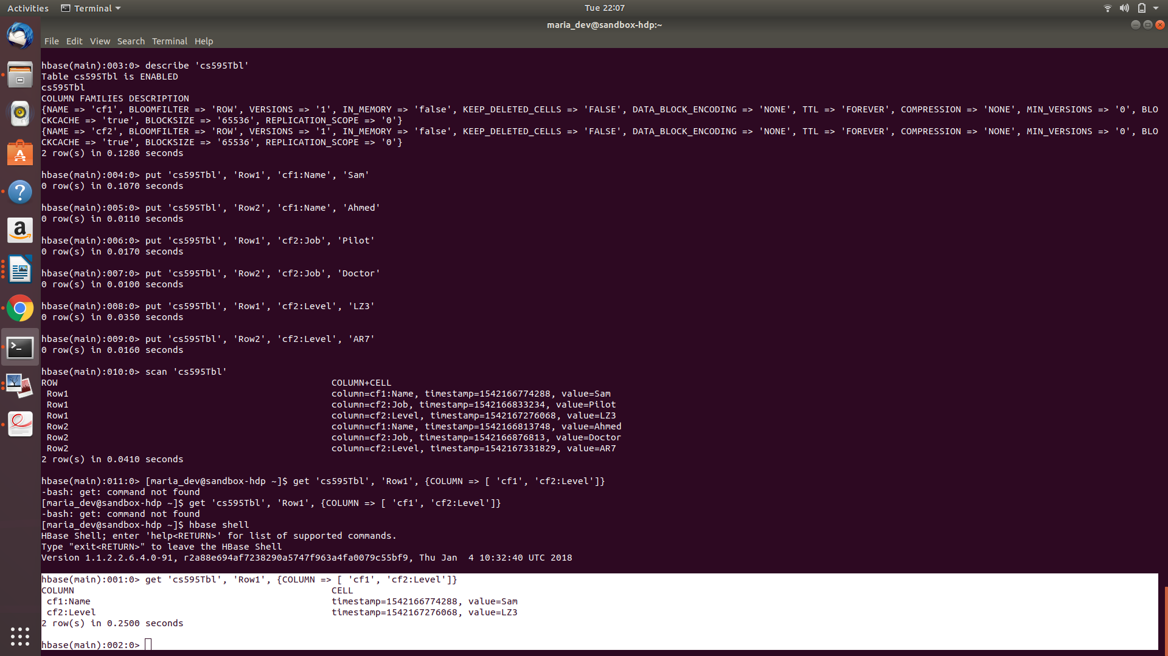

Exercise 4)

Using the above table write command that will get the value associated with row (Row2), column family (cf1) and column/qualifier (name). Provide the command and its result as the output of this exercise.

**Command Executed:**

get 'cs595Tbl', 'Row2', {COLUMN => [ 'cf1:Name']}

**Screenshots:**

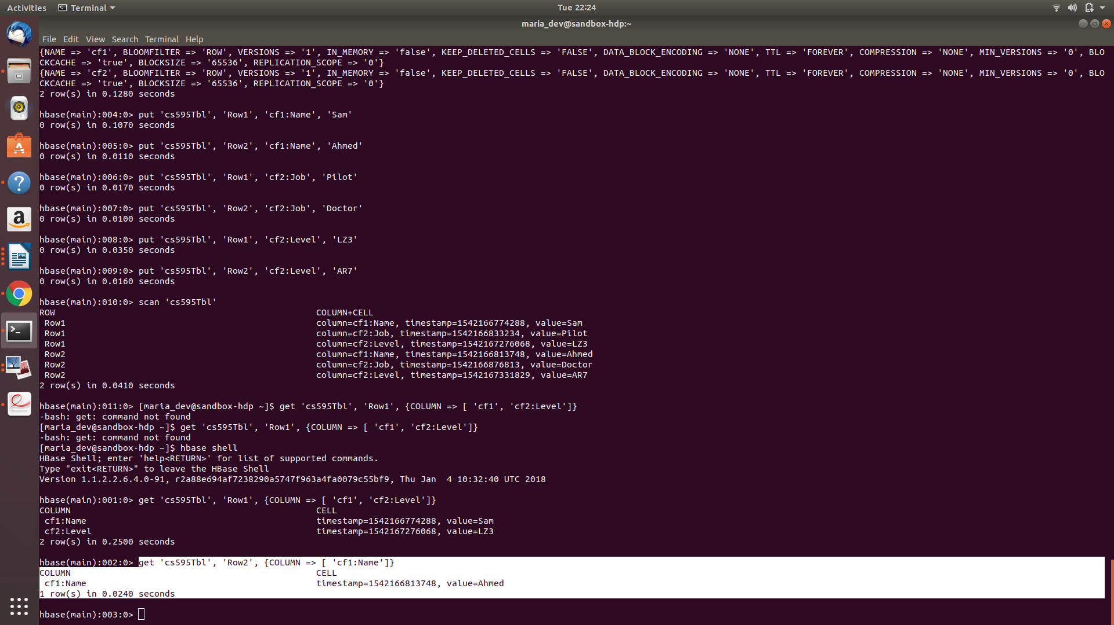

Exercise 5)

Using the above table write a SCAN command that will return information about only one row using the LIMIT modifier. Provide the command and its result as the output of this exercise.

**Command Executed:**

scan 'cs595Tbl', {LIMIT => 1}

Or

scan 'cs595Tbl', {FILTER => "(PrefixFilter ('Row1'))"}

**Screenshots:**

